Application for medicines described in CKS, NICE guidance and/or other national guidance
Name of guidance | SIGN155 Pharmacological management of migraine, first published February 2018, revised September 2022
Available at | https://www.sign.ac.uk/media/2001/sign-155-migraine-2022-v10.pdf

The APC will have 4 options when asked to consider the application/s:
- To accept
- To reject
- To allocate alternative traffic light classification
- To request a full evidence review.
The traffic light status for the Surrey PAD is available at: Traffic Light Status (res-systems.net)
This application is for Candesartan cilexetil [unlicensed indication] as prophylaxis in patients with episodic or chronic migraine, although there is limited evidence to support its use. It is not included in CKS or NICE however it is included in SIGN155, the BNF treatment summary, and the British Association for the Study of Headache (BASH) guidelines.
Its use is also supported by local neurologists and would give primary care prescribers another choice. Candesartan is a medicine which is well established and there is good experience of its use (within its licensed indications).
From the BNF Treatment Summary: https://bnf.nice.org.uk/treatment-summaries/migraine/
BASH guidelines: https://www.bash.org.uk/ or NATIONAL Headache Management SYSTEM FOR Adults 2018 (bash.org.uk)
NICE Guidance²: not listed in NICE guidance https://www.nice.org.uk/guidance/cg150, or in CKS https://cks.nice.org.uk/topics/migraine/prescribing-information/drugs-for-the-prevention-of-migraine/
First-line treatment : According to SIGN, first line treatment for acute attacks is aspirin or ibuprofen, then one of the (many) triptans available. For prophylaxis, SIGN and recommend :
- Propranolol : target dose 80mg twice a day – on PAD
- Topiramate : target dose 50mg twice a day (use if propranolol fails) – on PAD
- Amitriptyline/ other TCA : target dose 30-50mg at night – on PAD
- Candesartan: target dose – NOT on PAD
- Other prophylactic options are sodium valproate 600mg twice a day (avoid in women who may become pregnant – not on PAD) and pizotifen 3-4.5mg daily (lacking evidence, but widely used), on PAD.

Medicine name  (generic and brand) | State licensed indication and if use in this application is licensed? | Place in therapy | Does it require dose titration? | Does it require monitoring?  (SPC and SBS monitoring) | Recommended traffic light | Comments  Must include information about:  - whether a cost impact is expected and by how much.  - impact on workload, e.g. monitoring.
Candesartan (pg15 4.5 – see below) | Unlicensed – 16mg once daily | Migraine prophylaxis | Yes | BNF - Monitor plasma-potassium concentration, particularly in the elderly and in patients with renal impairment. | GREEN | Titration to 16mg target dose would be as used for licensed indications
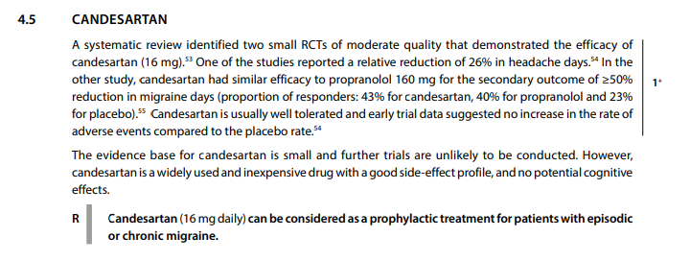

Identified lead for development of additional necessary documents e.g. shared care agreement
Name:
Designation:
Organisation:
Estimated date of preparation:

References:
- https://www.sign.ac.uk/media/2001/sign-155-migraine-2022-v10.pdf
- https://www.sign.ac.uk/media/2005/migraine-flowchart-2022.pdf

